We are manufacturer and dealer of various types of screw, different head style and driver types.

**Screw Types**

1. Wood Screw
2. Machine Screw
3. Sheet Metal Screw
4. Self-Drilling Screw
5. Set Screw

**Head Style**

1. Flat
2. Fillister
3. Oval
4. Pan
5. Truss
6. Round
7. Binding
8. Botton
9. PF
10. Cheese
11. Cylinder
12. With Washer

**Driver Types**

1. Phillips and Frearson
2. Slotted
3. Combination

**Photo Gallery**

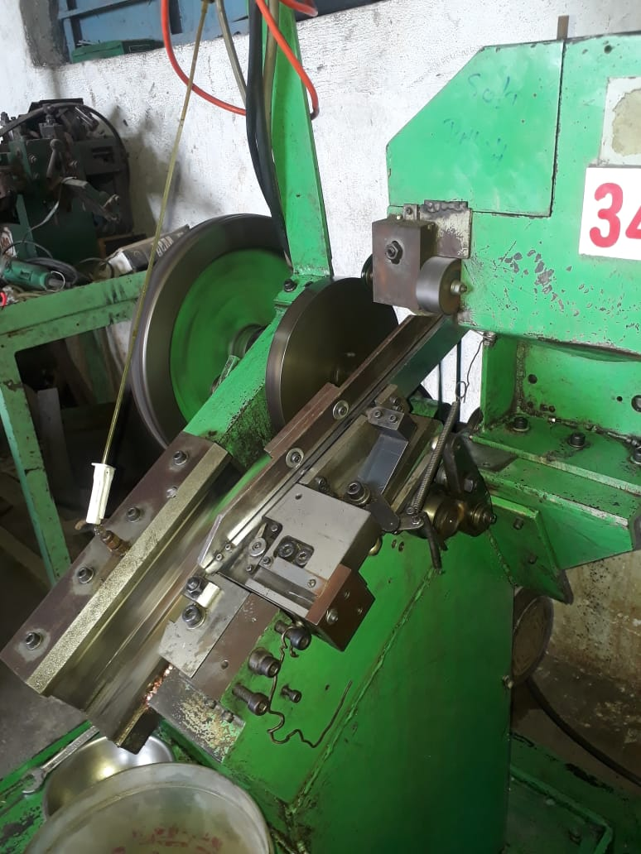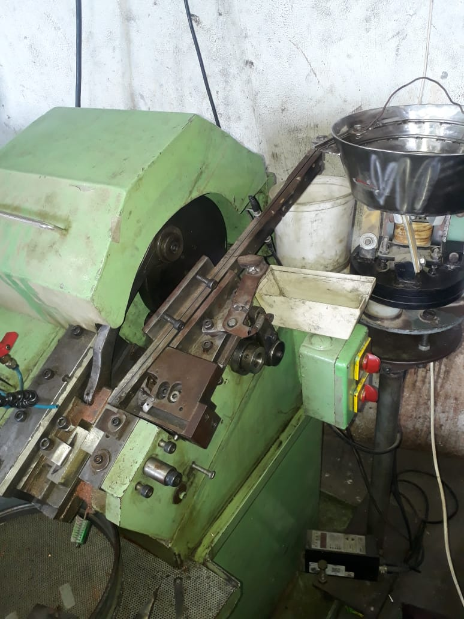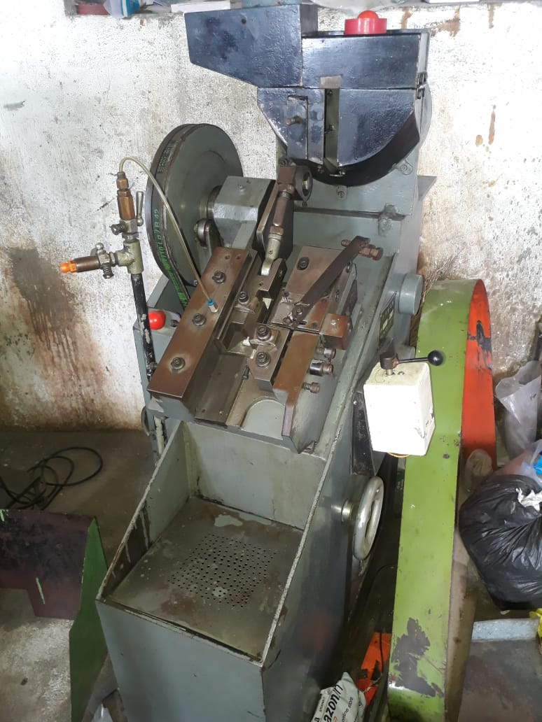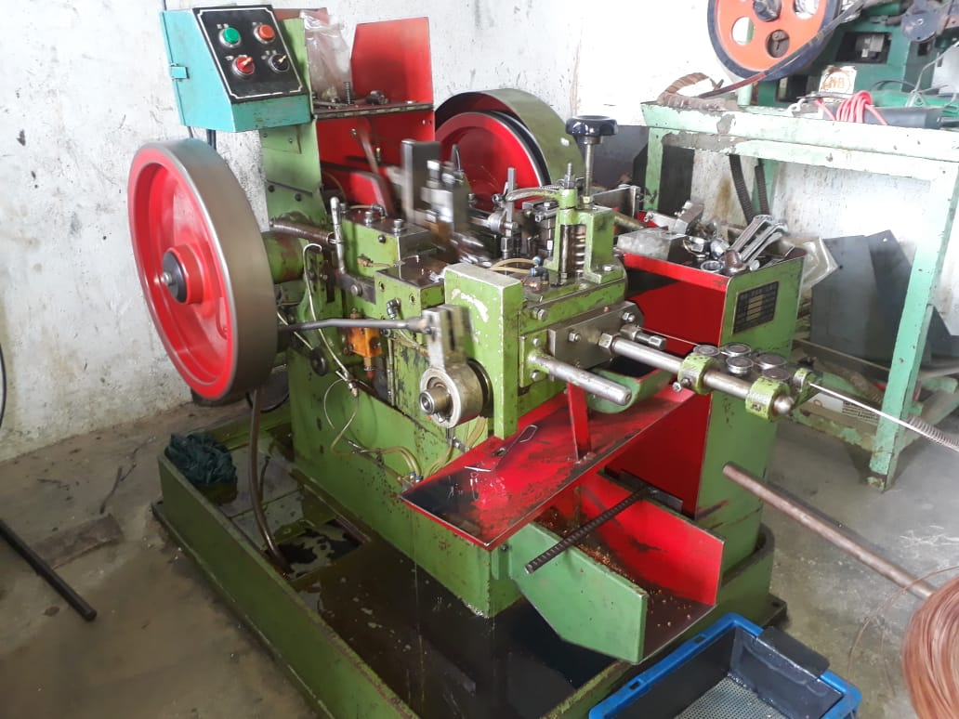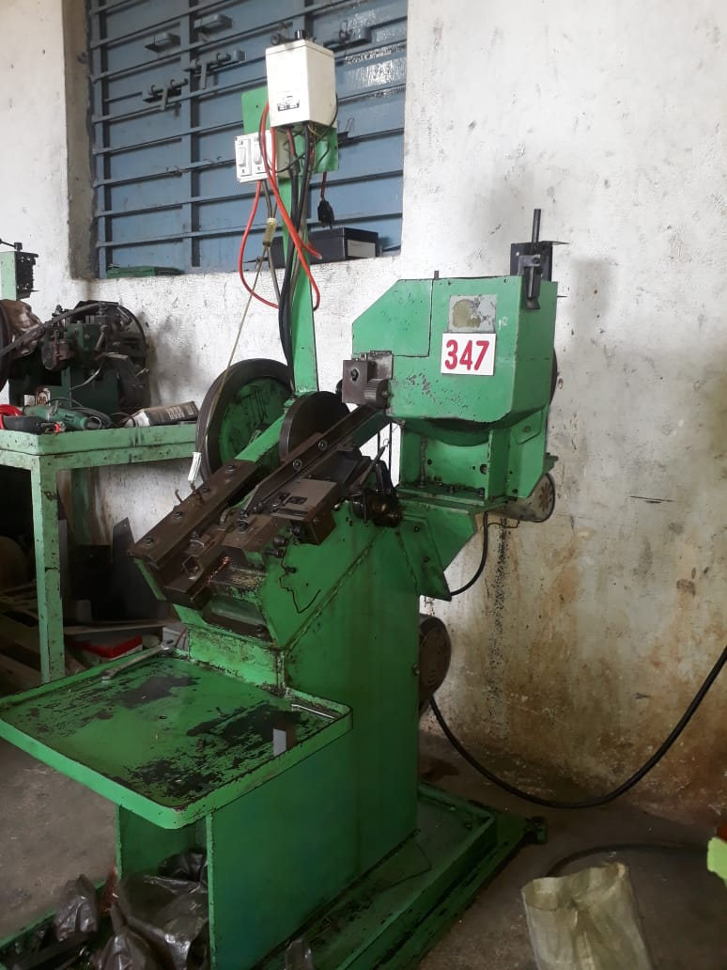

**Screws**

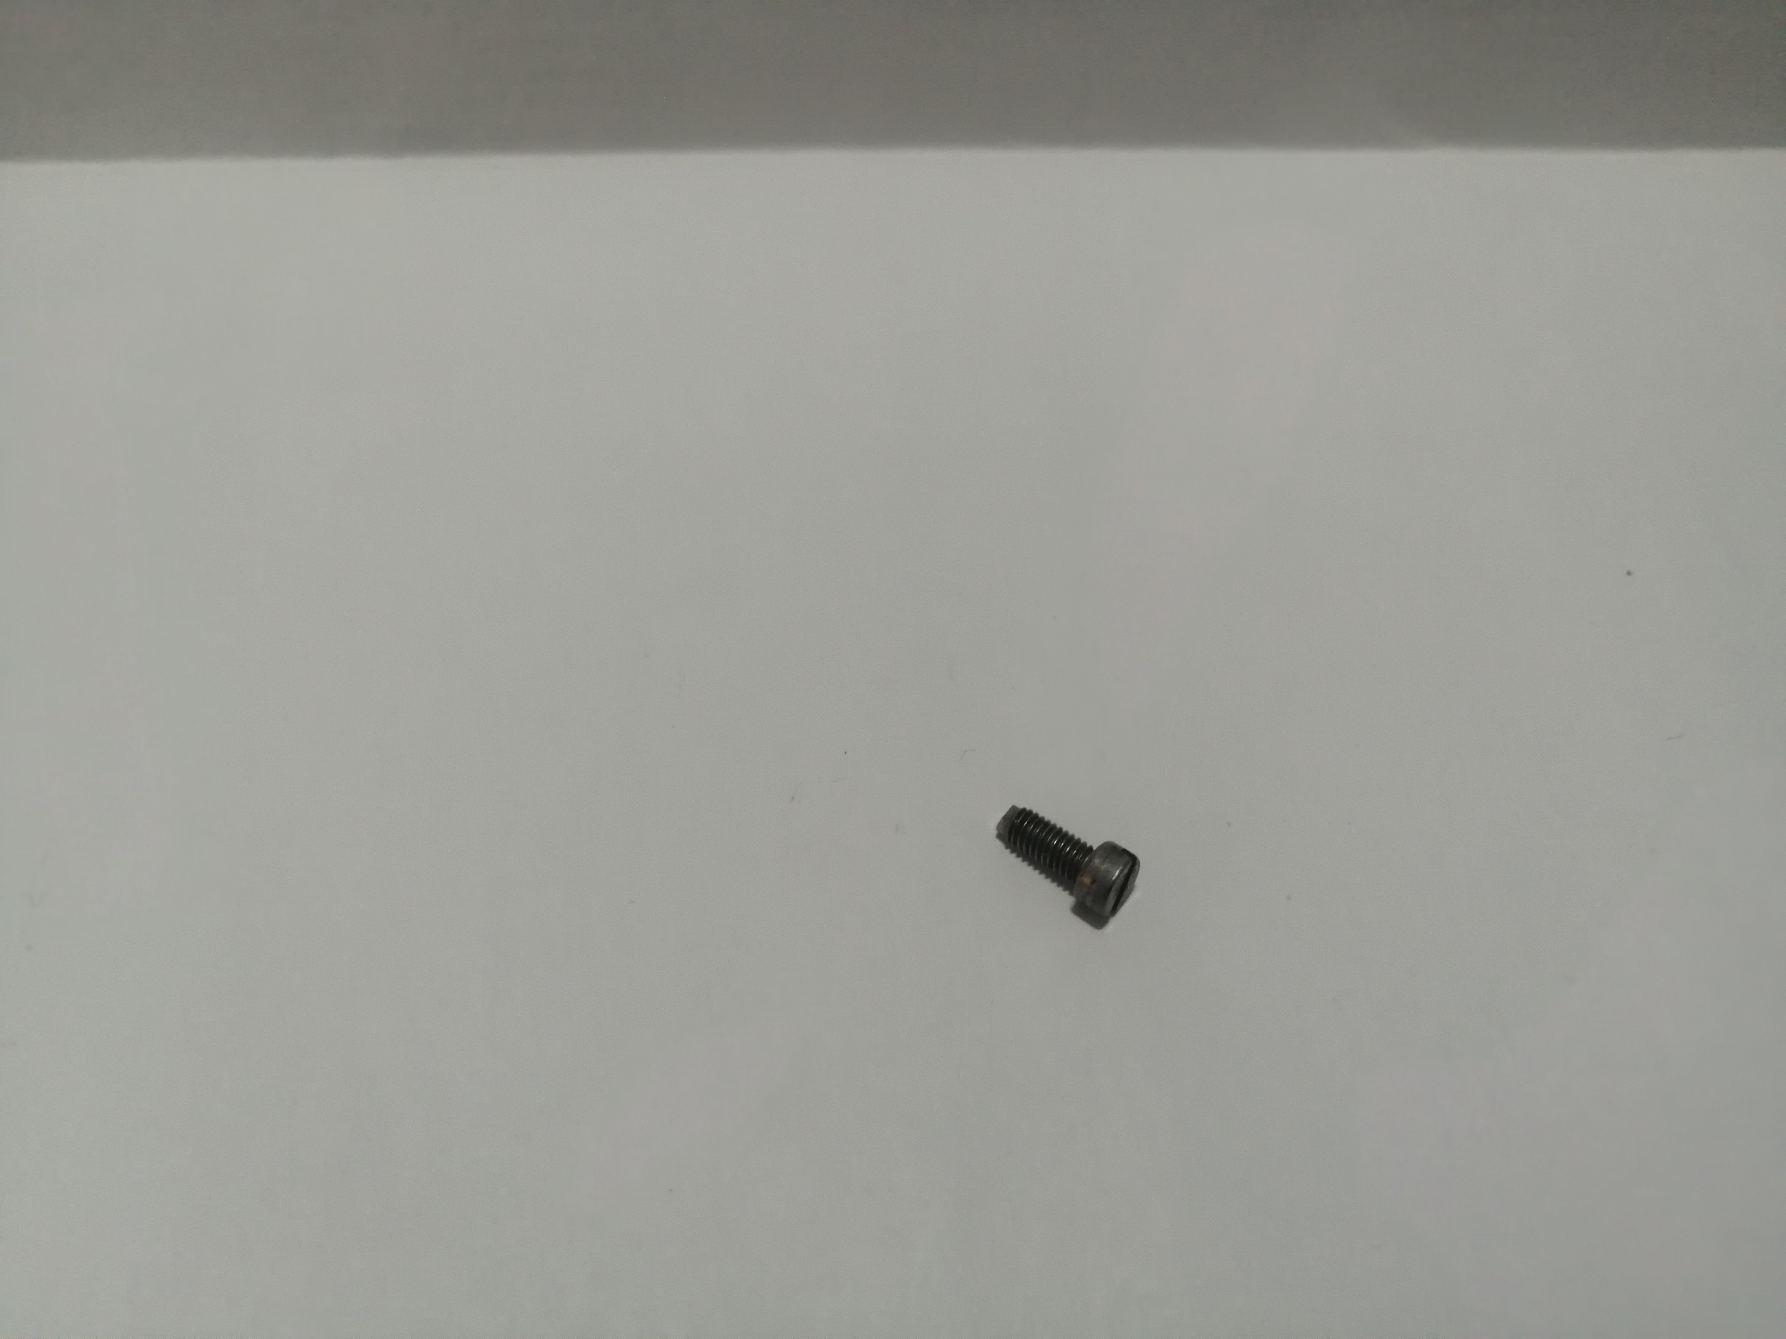

* Machine Screw, Fillister head, Slotted drive style

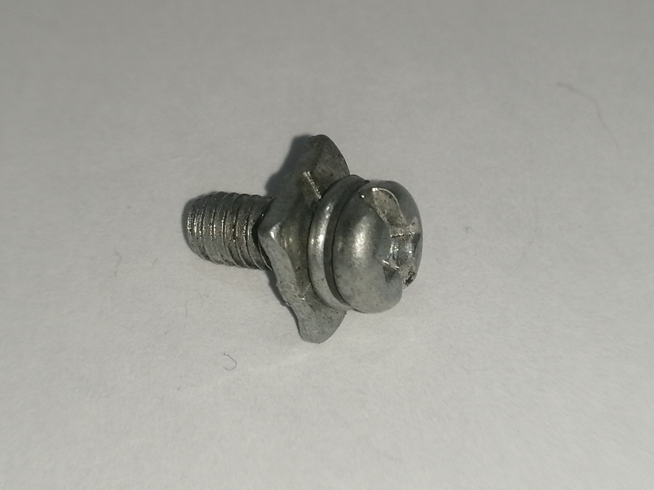

* 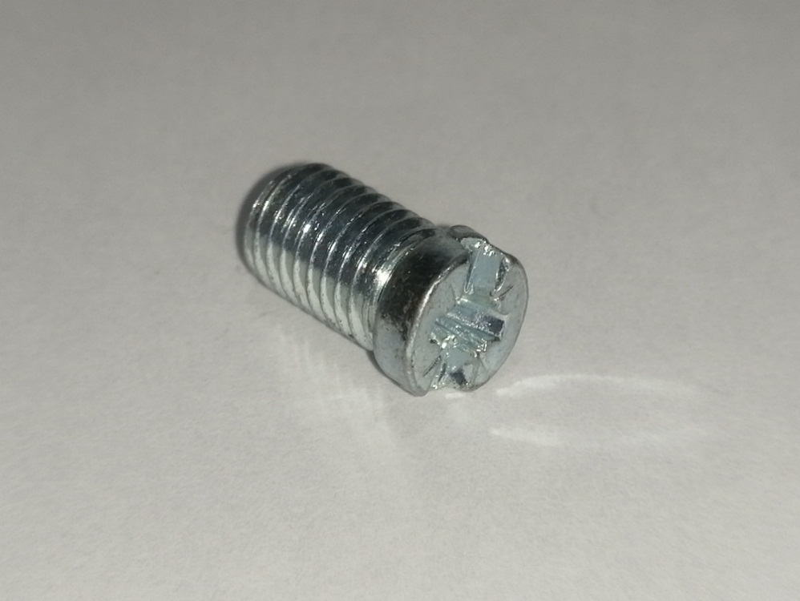Machine Screw, Pan Head with washer, combination drive style
* Machine Screw, Fillister head, combination drive style

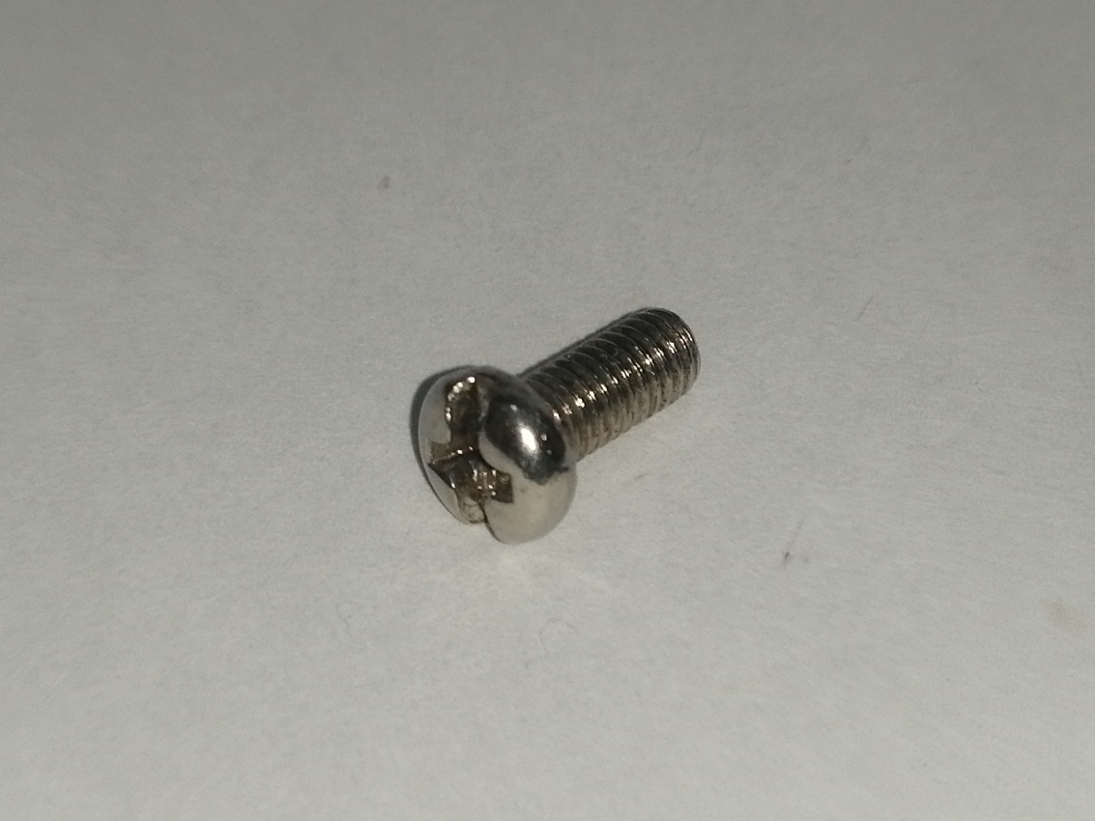

* Machine Screw, Pan Head, combination drive style

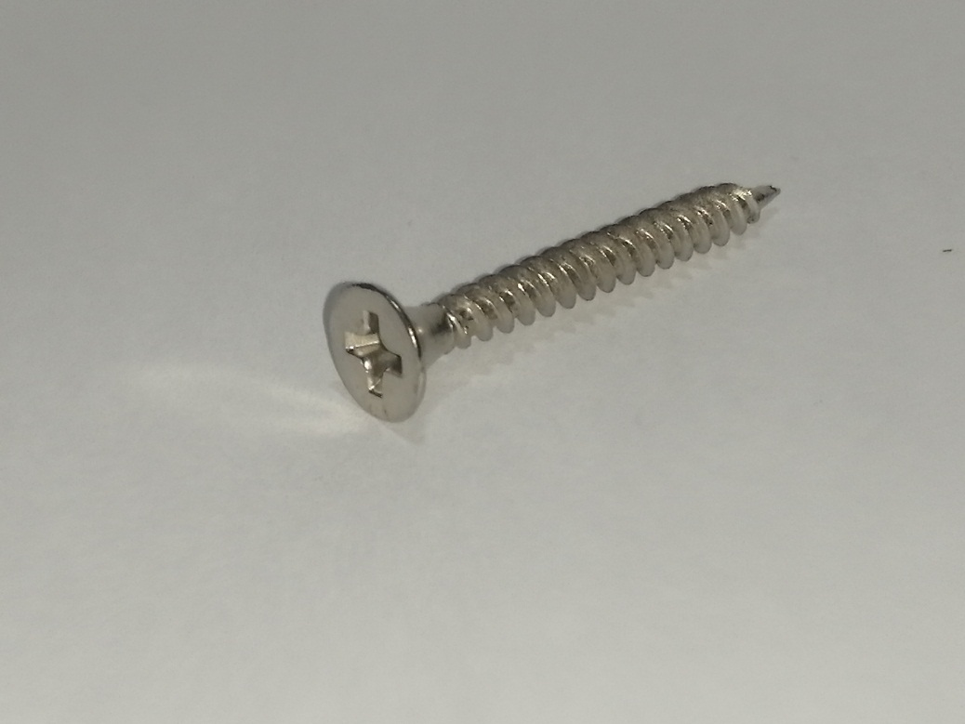

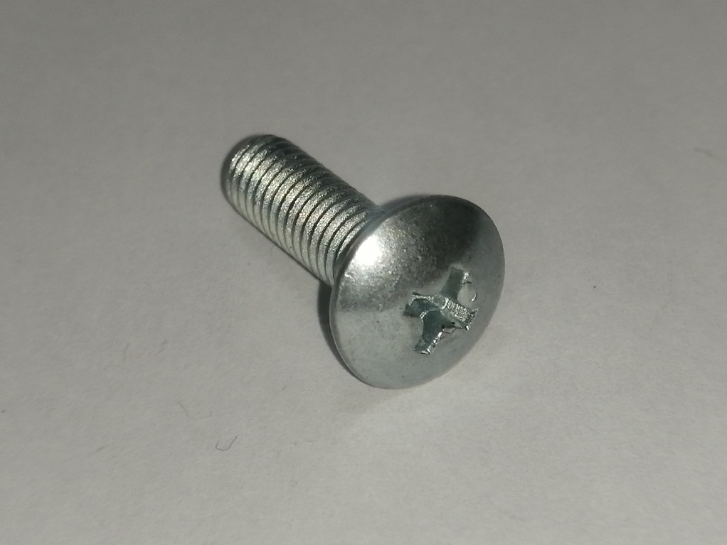

Machine Screw, Truss Head, Phillips drive style.

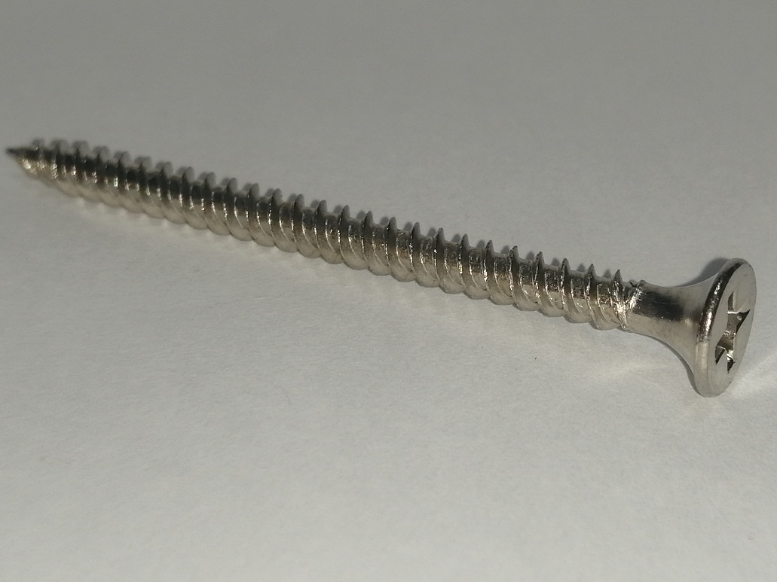

Self-Drilling Screw, Flat Head, Phillips drive style.

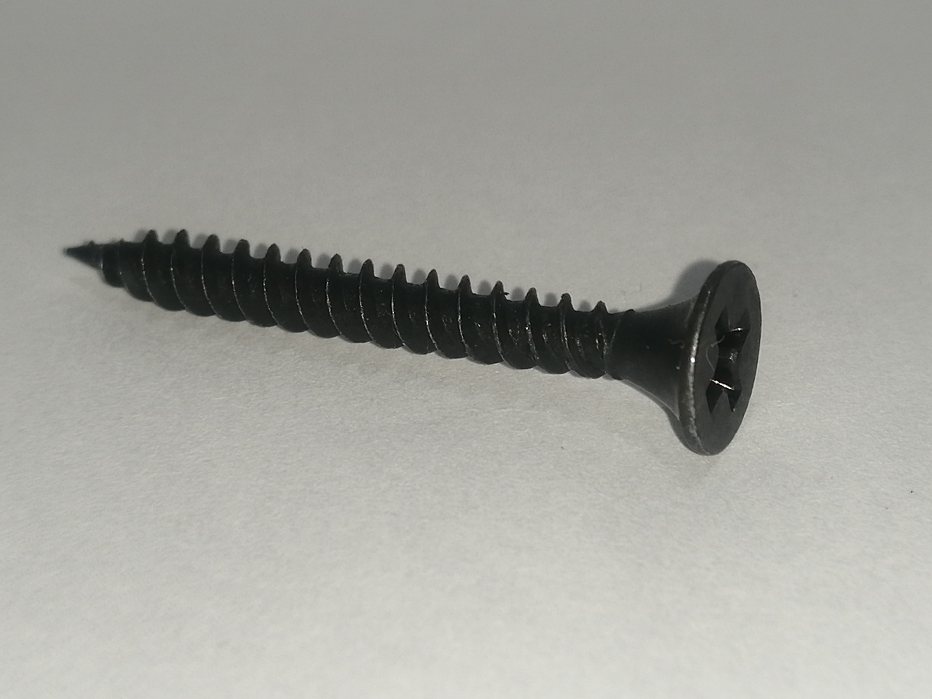

* Self-Drilling Screw, Flat Head, Phillips drive style. Coated